ONBOARDING GUIDE
NDIS Hub
The operating system for NDIS providers — participants, invoicing on the latest price guide, rosters, progress notes and an AI assistant in one calm dashboard.
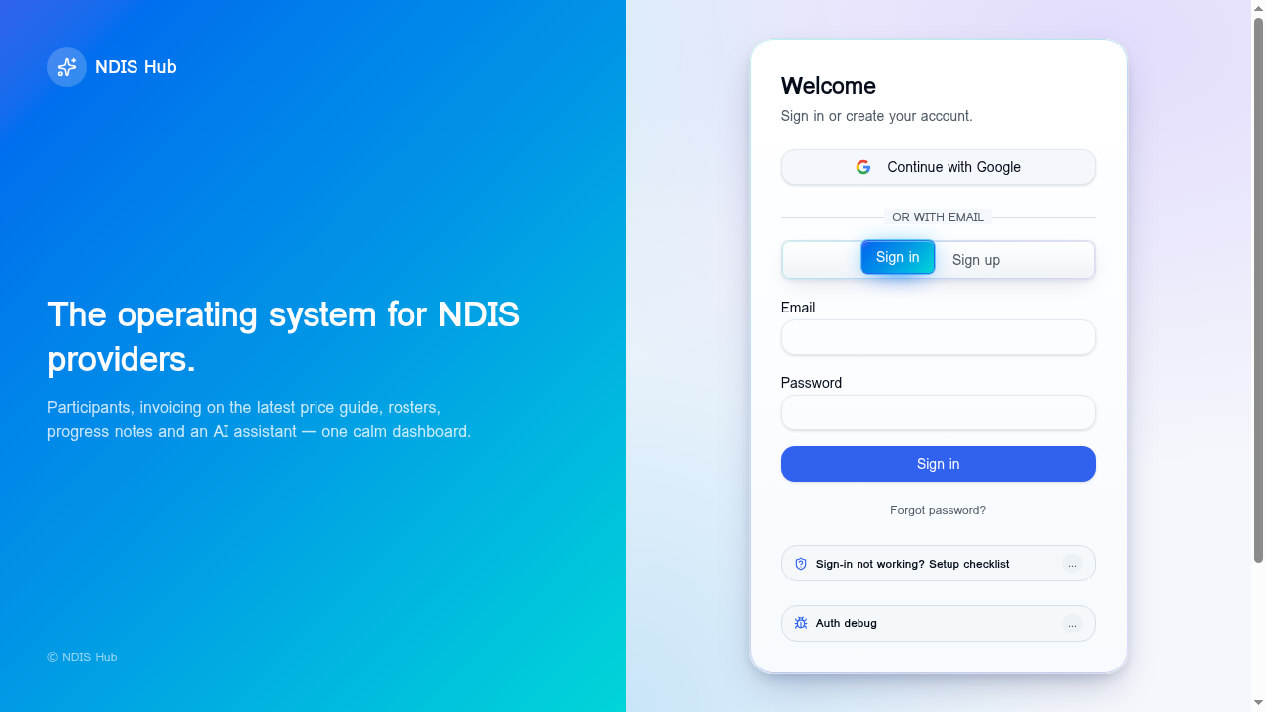
Branded sign-in with Google or email/password.
Welcome
This guide walks new NDIS providers through what NDIS Hub does, how the core workflows fit together, and how to get set up. The whole platform is designed around three goals: reduce admin time, keep participant records compliant, and make invoicing painless.
You can run NDIS Hub in any modern browser, or install it to your home screen for a native-app experience on iPhone, iPad, Android and desktop.

WHAT'S INSIDE
Core features
Every module shares the same participant, roster and invoice data — so a shift you log on Monday becomes an invoice line item on Friday without any retyping.
Participants register
Keep every participant's plan, NDIS number, budget and notes in one secure place. Status tags surface who's active, paused or off-boarded at a glance.
Smart invoicing
Generate compliant invoices from completed shifts in seconds. Auto-populates the latest NDIS price guide, calculates GST, and exports clean PDFs ready to email or upload to a plan manager.
Upload & auto-fill (AI)
Drop in a PDF or photo of an existing invoice and the AI parses participant, line items and totals — turning paperwork into a draft you only need to review.
Rosters & shifts
Schedule support workers against participants, track service codes, and convert completed shifts straight into invoice line items. No double-entry.
Progress notes
Date-stamped notes per participant covering goals, activities and outcomes. Filter, search, and export for plan reviews.
Reminders & calendar
Recurring reminders for plan reviews, reassessments and renewals. Optional email pings so nothing slips through.
AI assistant
A conversational helper that can summarise invoices, draft progress notes, surface budget warnings, and answer questions about your data — with permissions you control.
Reports & GST
One-click monthly summaries and GST exports. Send straight to your accountant or download as CSV/PDF.
Install as an app
Add NDIS Hub to your phone or tablet home screen for a full-screen, offline-capable experience — no app store required.
Privacy & audit log
Row-level security on every record, a complete invoice audit trail, and admin tooling for auth and access — built for sensitive participant data.

PLANS
Pricing that scales with your practice
Start on Starter for solo coordinators, move to Growth when you add support workers and the AI assistant, and unlock unlimited everything on Scale. Annual billing saves around 17%.
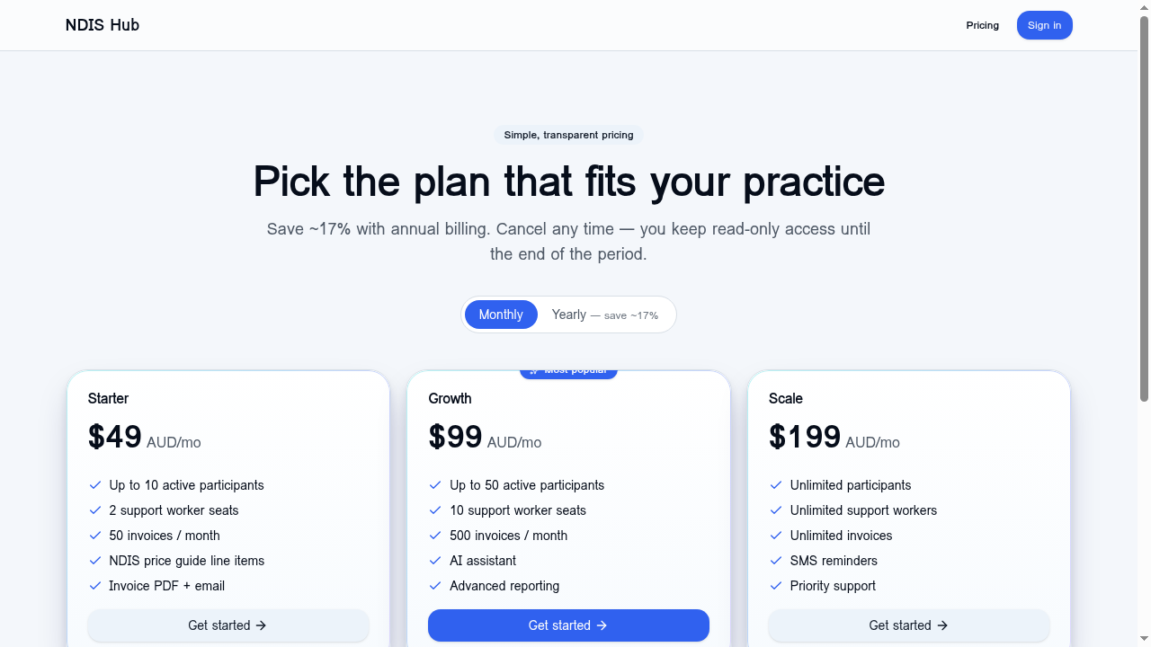
Starter, Growth and Scale plans — monthly or yearly.

GETTING STARTED
Your first 30 minutes
1. Create your account
Sign up with Google or email. Confirm your email address and you'll land on a clean dashboard.
2. Set up your business profile
Add your ABN, business name, contact details and logo. These appear on every invoice you issue.
3. Add your first participants
Enter NDIS numbers, plan dates and budgets. You can paste in details from existing spreadsheets.
4. Add support workers and roles
Invite workers and assign role permissions (admin, manager, support worker).
5. Schedule your first shift
Use the rosters view to schedule a shift against a participant, with the matching NDIS service code.
6. Generate your first invoice
From completed shifts, click Create invoice — the line items, GST and total are pre-filled.
7. Install on your phone
Open the Install guide and add NDIS Hub to your home screen for instant access.
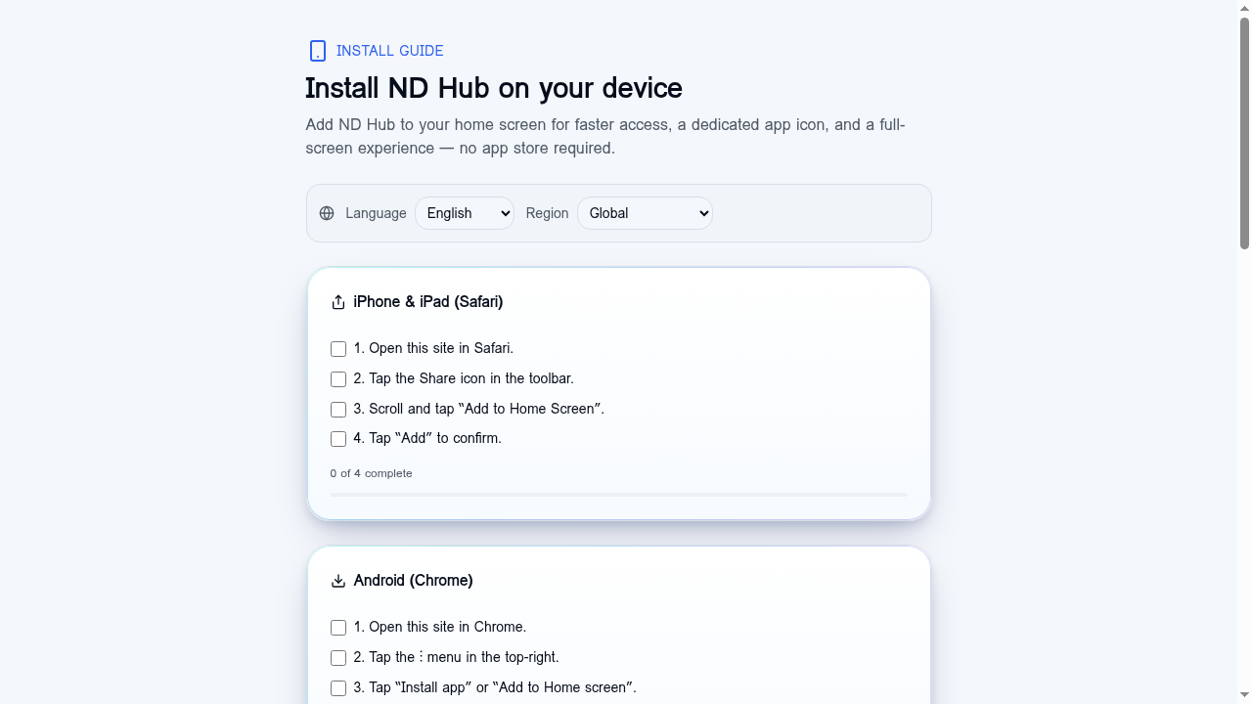
Step-by-step install guide for iOS, Android and desktop.

PLAN COMPARISON
At a glance
Plan | Best for | Highlights
Starter — $49/mo | Solo coordinators | 10 participants, 50 invoices/mo
Growth — $99/mo | Small teams | 50 participants, AI assistant, advanced reports
Scale — $199/mo | Established providers | Unlimited participants, SMS reminders, priority support

NDIS Hub · ndi-ai-viper.app · © NDIS Hub

